This resource is an introduction to the advisor dashboard in Workday.

The advisor dashboard is the hub for advising activities and advisee information. Growing familiar with the advisor dashboard will help you complete your work quickly and easily.

INSTRUCTIONS
- Log into Workday and click the Faculty Teaching & Advising app from the homepage.
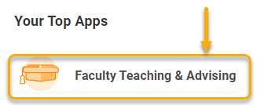
TIP: If you do not see this app, click the Menu in the top left-hand corner.
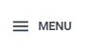
Click “Add Apps”
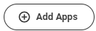
Type “faculty teaching” in the search bar and click to add the app to your homepage.

- The Faculty Teaching & Advising app has 3 tabs. The two most important are the Advisees tab and the Advising Tasks tab.

See below for an overview of these two tabs.

Advisees Tab
The advisees tab lists your student advisees in the My Students – Advising table. From this table you can view each student, access their record, review and remove holds, and locate contact information.

TIP: Throughout Workday, right-click and open pages in a new tab. This way you can simply close the tab when finished and return to the table.
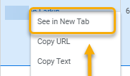

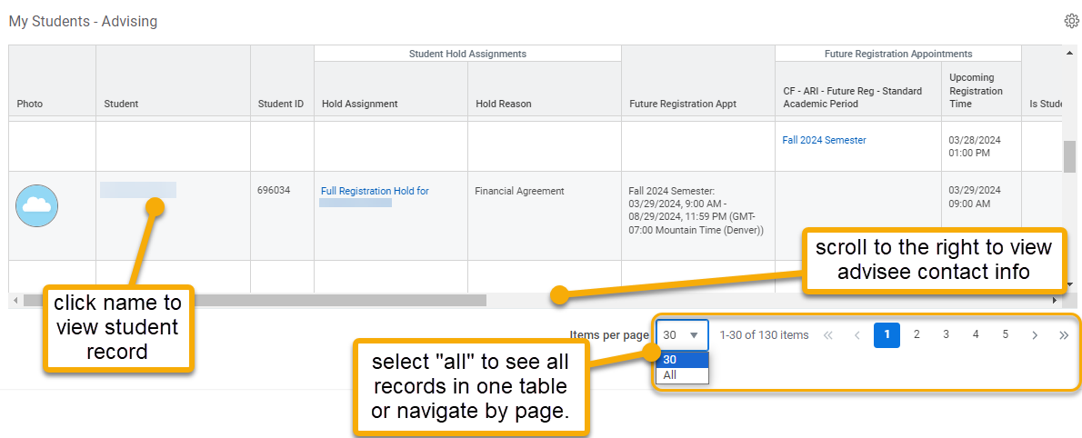

Many tasks can be accomplished through this table. For example, to remove advisor holds, click the student’s name to go directly to the student’s record. (See the Remove Advisor Holds guide for details.) Additionally, through the student record you can view the student’s Academic Progress Report, other active holds, and enrolled and waitlisted courses.

Advising Tasks tabs

The most frequently used items in the Advising Tasks tab are described below.

Item | Description
Add Student Note  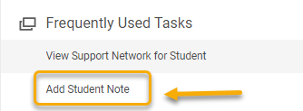 | Student notes can be shared between advisors and administrators. For more information, see the Add Student Note guide.
Course Search  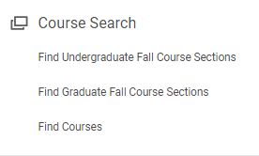 | Course search is a helpful tool when researching courses on behalf of, or with a student. The Western Course Look-Up Tool is best used for general search. Course search in Workday is best used to prepare for registration.  